1. Create one IAM user and assign ec2, s3 full access role.

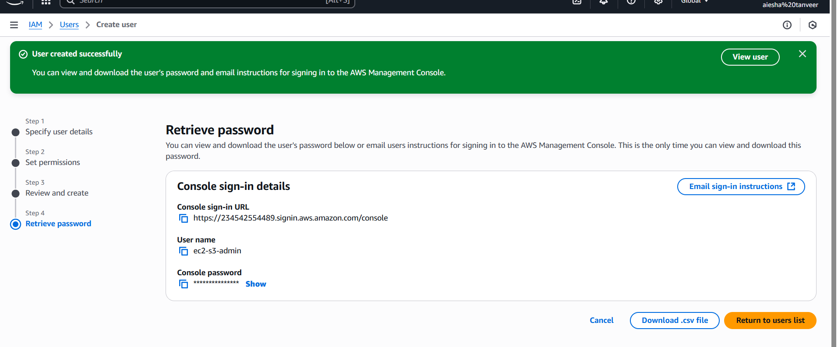

1. Create one group in IAM and assign read access for ec2.

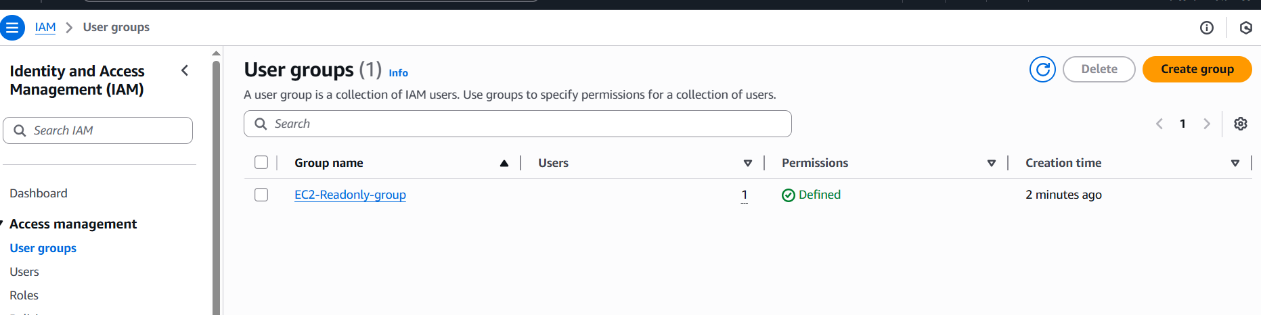

1. Create a new user with name Devops and add to the group created in task2.

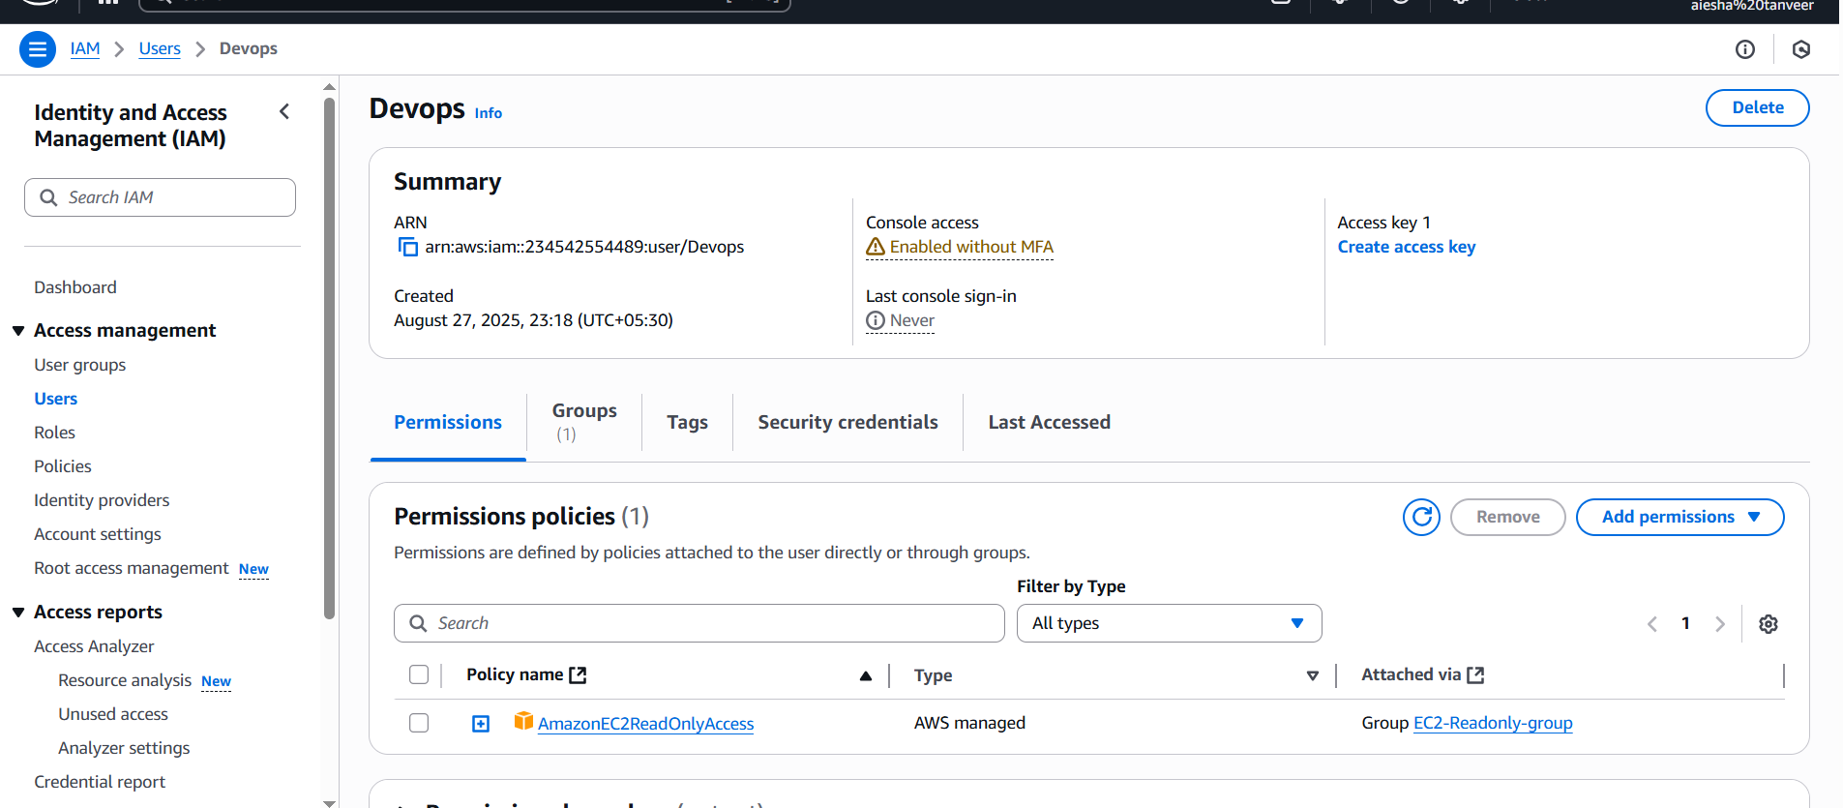

1. Write a bash script to create a IAM user with VPC full access.

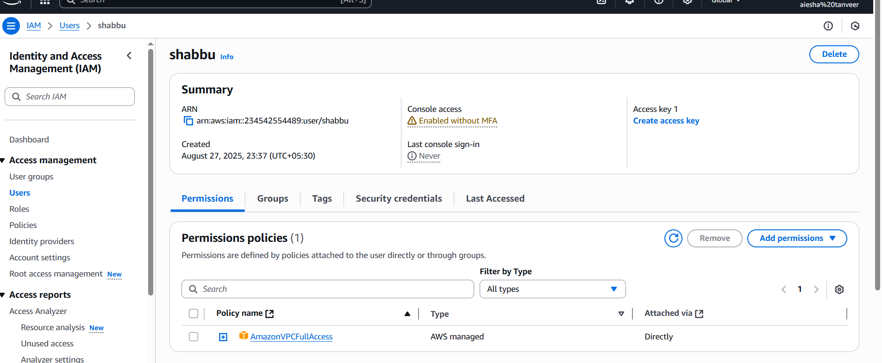

1. Create a IAM policy to access ec2 for a specific user in specific regions only.

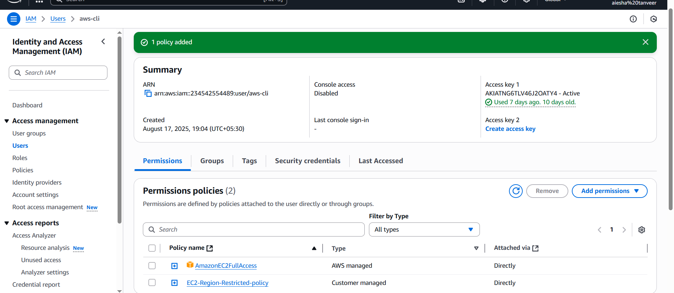

1. We have two accounts account A and account B, account A user should access s3 bucket in account B.

(collaborate with team member and execute this. Mostly asked in every interview.)